King or Queen

If you have a Twister mat, it’s great for this!
Alternatively, colour some paper plates and allocate points per colour.
Using beanbags, ask residents to throw beanbags at the spots.
First one to reach 20 points is King or Queen for an hour.
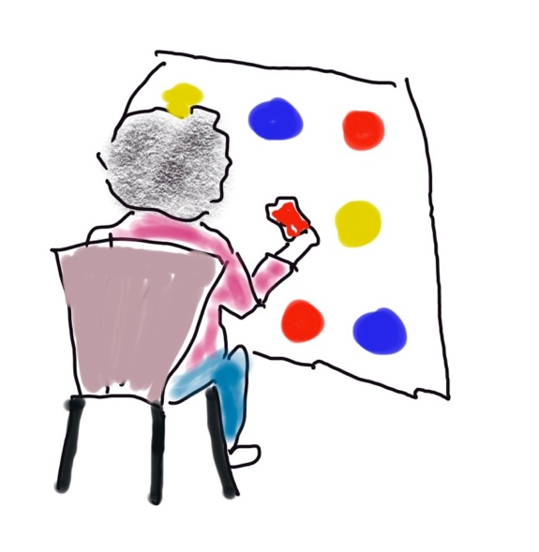
Make a crown from gold card. Or plain white card. Embellished with anything to make it look regal.
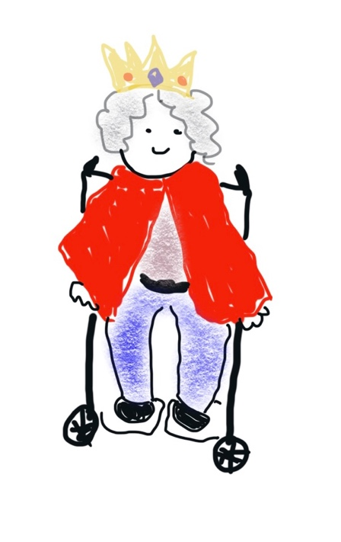
https://www.firstpalette.com/craft/paper-crown.html

If you have a red santa cape, use this as robes.
Go the whole mile and decorate a wheelchair
to walk your King or Queen around other
residents so they can wave.

www.alisonjmoore.com

